Assignment 10

Chaiwat Plongkaew 2021326660023

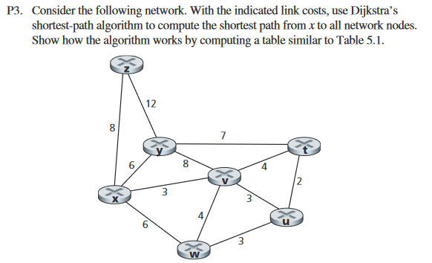

Ans

|  |  |  |  |  |  |  |
| --- | --- | --- | --- | --- | --- | --- |
| N’ | D(t), p(t) | D(u), p(u) | D(v), p(v) | D(w), p(w) | D(y), p(y) | D(z), p(z) |
| **x** | infinite | infinite | 3,x | 6,x | 6,x | 8,x |
| x**v** | 7,v | 6,v | **3,x** | 6,x | 6,x | 8,x |
| xv**u** | 7,v | **6,v** | 3,x | 6,x | 6,x | 8,x |
| xvu**w** | 7,v | 6,v | 3,x | 6,x | 6,x | 8,x |
| xvuw**t** | 7,v | 6,v | 3,x | 6,x | **6,x** | 8,x |
| xvuwt**y** | 7,v | 6,v | 3,x | 6,x | 6,x | 8,x |
| xvuwty**z** | 7,v | 6,v | 3,x | 6,x | 6,x | **8,x** |

N’ = Subset of nodes

D(t) = Least cost path of node t

p(t) = Previous node (neighbor of t) along the current least-cost path from the source to t.

The following are shortest paths from x along with their costs:

t: xvt = 7

u: xvu = 6

v: xv = 3

w: xw = 6

y: xy = 6

z: xz = 8

Ans

Dx(x) = 0

Dx(y) = min{c(x,y) + Dy(y), c(x,z) + Dz(y)}

Dx(z) = min{c(x,y) + Dy(z), c(x,z) + Dz(z)}

Construct the distance vector table for node z from the network diagram:

|  |  |  |  |  |  |
| --- | --- | --- | --- | --- | --- |
|  | u | v | x | Y | z |
| v | infinite | infinite | infinite | infinite | infinite |
| x | infinite | infinite | infinite | infinite | infinite |
| z | infinite | 6 | 2 | infinite | 0 |

Now update the table with costs of all the neighboring nodes.

|  |  |  |  |  |  |
| --- | --- | --- | --- | --- | --- |
|  | u | v | x | y | z |
| v | 1 | 0 | 3 | infinite | 6 |
| x | infinite | 3 | 0 | 3 | 2 |
| z | infinite | 6 | 2 | infinite | 0 |

Update the table with minimum costs using the distance vector routing algorithm:

|  |  |  |  |  |  |
| --- | --- | --- | --- | --- | --- |
|  | u | v | x | y | z |
| v | 1 | 0 | 3 | 3 | 5 |
| x | 4 | 3 | 0 | 3 | 2 |
| z | 6 | 5 | 2 | 5 | 0 |

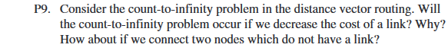

Ans

The count-to-infinity issue does not arise if a link's cost is reduced since nodes will identify their new least expensive links based on the updates they get and will then provide updates for the distance vector.

If we connect two nodes, the cost-to-infinity problem prevents proper data propagation, and attempts to locate the lowest-cost pathways lead to mistakes.